AKASH V



**About Me**



+91 9663177124



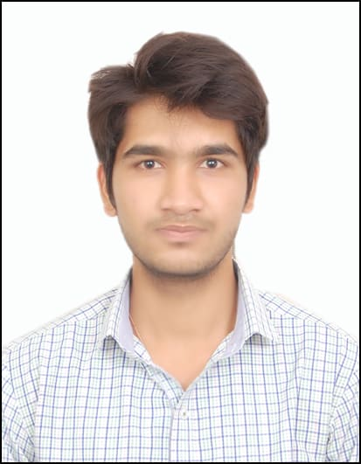





2+ years’ experience  May 10, 1996  Bangalore, India Linkedin.com/in/akash-veer

**Full Stack Developer**



[akashveer98@gmail.com](mailto:akashveer98@gmail.com)

* Currently working as a **Software Engineer at Eurofins IT Solutions India.**





**Education**

Bachelor of Engineering in Computer Science. Graduated, July 2018

MVJ College of Engineering. Marks 75% Visvesvaraya Technological University First class Distinction

Bangalore, India





**Professional Certifications**

* Certificate for completion of foundation program by **Infosys** campus connect on **Java, RDBMS and Web programming.**





**Career Highlights**

* **2+ Years of total experience** in the field of Software Development and Programming with expertise in **Full stack development.**
* Hands on work experience on **Microsoft Azure Cloud,** **C#, Asp.Net, MVC5, Entity Framework, SQL Server, Angular 8, HTML, CSS, JavaScript, TypeScript and Bootstrap.** Used IDE as Visual Studio(2017, 2019), Visual Studio Code.
* **TFS** as Version-control systems for tracking and submitting changes in the source code.
* Experience working on **DevExpress, Dynamics 2012 interfaces.**





**Skills**

|  |  |  |
| --- | --- | --- |
| * C# * .Net Technologies * Entity Framework * MVC5 * Core Java | * SQL Server, AWS RDS * Angular 5+ * CSS * HTML * C | * TypeScript * JavaScript * Bootstrap * TFS * C++ |





**Work Experience**

|  |
| --- |
| **Project 1 : Significant Highlights** |
| Project: **Eurofins Discovery (E-commerce website)**  Client: **Eurofins Scientific**  Employer: **Eurofins IT Solutions India**  Skills: **SQL Server, C#, Asp.Net, MVC5, Entity Framework, Angular 5, HTML, JavaScript, TypeScript, CSS, Bootstrap, MS Unit Tests.**   * Developed E-commerce website for end users to add assays to cart, create quote, create sales order and interface to sync data to ERP system.   **Roles & Responsibilities**   * + Using Entity Framework to create tables and LINQ to query the data.   + Developed business functionality for quote creation and cart management.   + Developed APIs for Front end communication.   + Designed and developed webpages for the website.   + Wrote MS Unit Test cases for all the business functionality code. |

|  |
| --- |
| **Project 2 : Significant Highlights** |
| Project: **One Report (Report Management web portal)**  Client: **Eurofins Scientific**  Employer: **Eurofins IT Solutions India**  Skills: **SQL Server, C#, Asp.Net, MVC5, Entity Framework, Angular 5, HTML, JavaScript, TypeScript, CSS, Bootstrap, MS Unit Tests, DevExpress.**   * Developed .Net project for designing and generating reports from Experimental results   and web portal for Lab and client users to download and approve by digitally signing the reports.  **Roles & Responsibilities**   * + Using Entity Framework to create tables and LINQ to query the data.   + Developed business functionality for data binding to report templates.   + Developed APIs for Front end communication.   + Developed Web designer for end users to design report templates.   + Designed and developed webpages for the website.   + Wrote MS Unit Test cases for all the business functionality code. |



**Languages**

|  |  |  |
| --- | --- | --- |
| * English | * Hindi | * Kannada |
|  |  |  |



**Personal Interests**

|  |  |  |
| --- | --- | --- |
| * PC games | * Gym | * Swimming |
| * Listening songs | * Cricket, carrom, Volleyball, Badminton | * Nature Lover |
|  |  |  |



**Personal Details**

|  |  |
| --- | --- |
| * Father’s Name: Annappa I V * DOB: 10th May 1996 | * Native: Belgaum, Karnataka, India. * Marital Status: Single |
| * Gender: Male | * Nationality: Indian |
|  |  |

**Declaration**

I, Akash A V, hereby declare that the information contained herein is true and correct to the best of my knowledge and belief.

___________________________  
 Akash V Bangalore, India